SOUTH DAKOTA MUSIC EDUCATION ASSOCIATION
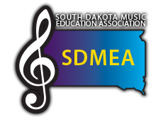
FOR IMMEDIATE RELEASE

{City, State} – South Dakota Music Education Association will present the Middle School All-State Band, taking place at the Huron High School on March 1, 2 2019, and featuring grades 6-8 in the state of South Dakota in the 20th year of the event.
SDMEA is proud to bring composer and conductor, Tyler S. Grant to the event this year. He has commissioned a work special for our celebration this year! The Middle School All-State Band will also be under the direction of South Dakota State University’s Dr. Jacob Wallace to work with the two honor groups.
Ticket sales will begin Saturday, March 2nd at the Huron High School at 1:45 pm. Tickets are $5.00 and children 18 and under are free. Tickets are general admission. The concert will begin at 3:00 pm.
Tyler S. Grant states “his commissioned work is depicting the geography and folklore of Badlands National Park. It is programmatic in nature and will be a great homage to one of the state’s landmarks and one that serves as a great opportunity for musical growth in the students at honor band!”

The mission of the National Association for Music Education is to advance music education by promoting the understanding and making of music by all. SDMEA is a state affiliate of the National Association for Music Education. With over 400 members, SDMEA is the largest association of instructional musicians in the state catering to the needs of band, choral, general music and orchestral teachers.

